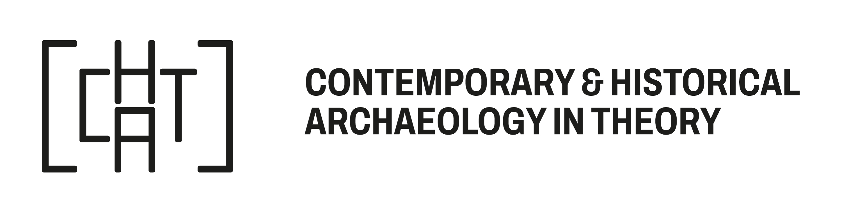
CHAT Hope, University of Innsbruck, 29-31 October 2026

About CHAT’s Bursary Award

When funds are permitting, CHAT’s Standing Committee makes an annual bursary award to enable attendance at CHAT meetings. The 2026 award will be subject to a maximum of €150 for each successful candidate.

CHAT’s Standing Committee will prioritise the following groups: first time attendees, students, non-EU/UK and non-US participants and those on low incomes. Applicants may be located in any part of the world. The Committee will not favour presentation over attendance. The award can be spent on registration/travel/hotel costs/childcare costs. Payments will be made before the meeting but are dependent on registration.

The deadline for receipt of applications is 14 October 2026 at 4pm BST.
Please complete this form and once completed, please email the form to cont.hist.arch@gmail.com. We aim to notify applicants by 22 October 2026.

Title and full name
Email address
Affiliation
Address
Total funds requested from CHAT
Please tell us why attendance at a CHAT meeting would be useful and any expected outcomes from attendance (in 300 words or less)

Applicant signature
Date

